Adult membership $40 Family $45 Junior Free until 18yrs old

Juniors (including grandchildren) are covered by Family membership

Pay online Bank Account 030435 0477406 00 Initial and surname as ref

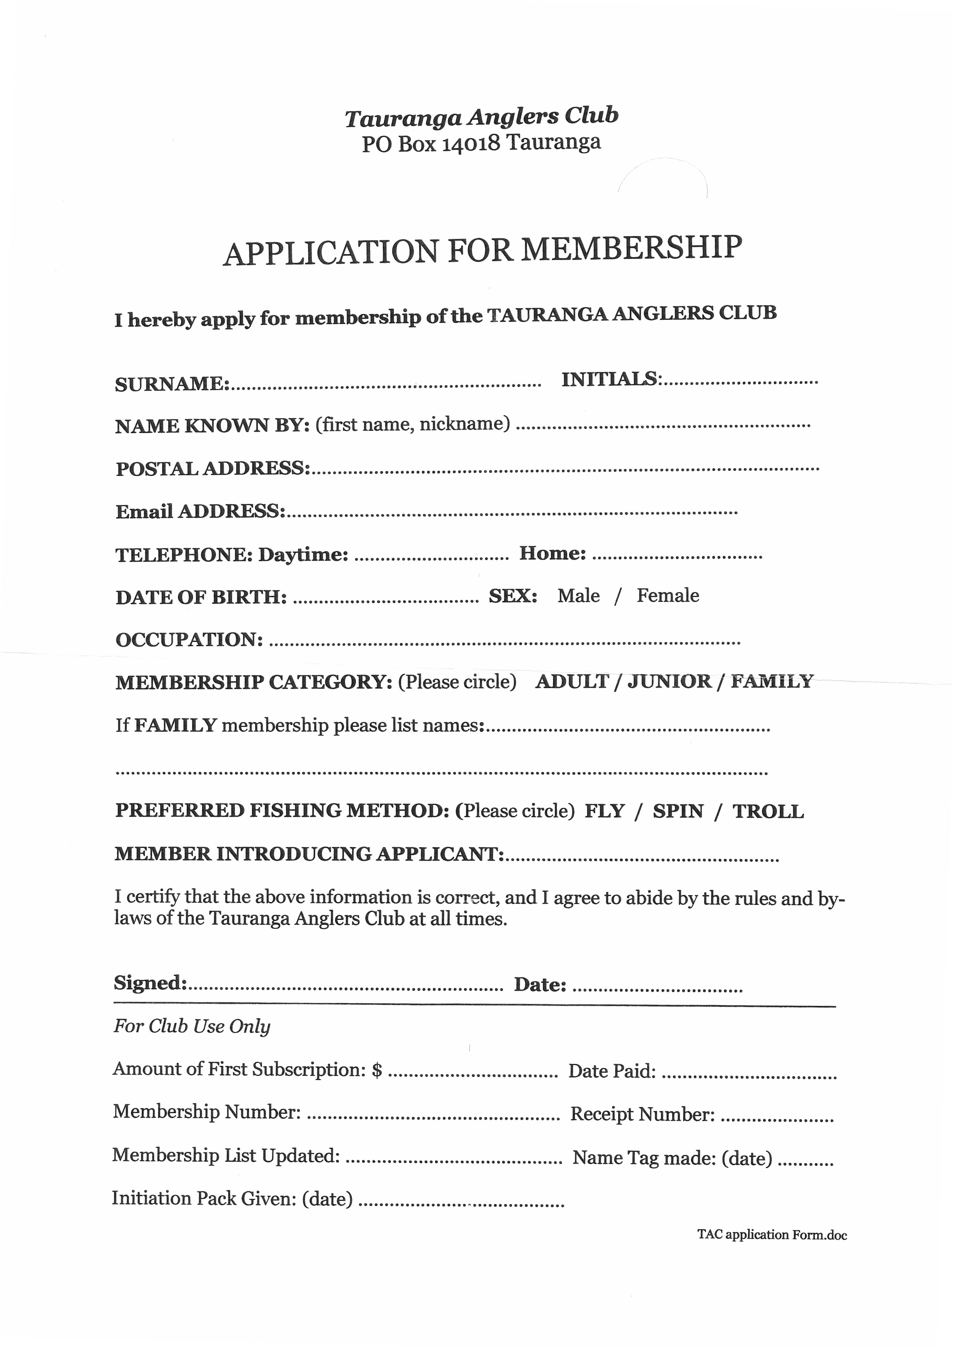

taurangaanglersclub@hotmail.com